BREAKDOWN DAN NASKAH
Iklan Layanan Masyarakat
Sekolahku
Scene 1/1
No | Time Shoot | Location Shoot | Talent | Wardrobe | Property | Equiipment Shoot | Duration Shoot
 | 20/03/2013  Pukul 06.00-06.30 | Desa Lopait  Jl.fatmawati Rt/Rw 11/01 |  |  |  | -Kamera Sony HD  -Lensa 50mm  -tripot  -kamera DSLR | 5 detik
 | STORYBOARD |  |  | VIDEO |  | AUDIO
 | 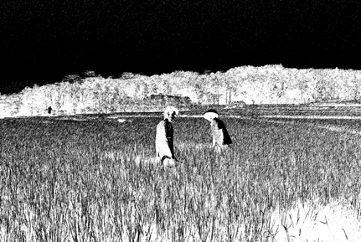 |  |  | Till Down to LS : Suasana di sawah sebuah desa |  | Backsound : Iwan Fals (Tugu Pancoran)

CHECKLIST (PRODUCTION)
Talent | Wardrobe | Property | Equipment | Shootlist
ok | ok | ok | Ok | M2U04103
BREAKDOWN DAN NASKAH
Iklan Layanan Masyarakat
Sekolahku
Scene 1/2
No | Time Shoot | Location Shoot | Talent | Wardrobe | Property | Equiipment Shoot | Duration Shoot
 | 20/3/2013  Pukul 07.00-07.20 | Sawah ,dekat Desa Lopait  Jl.fatmawati Rt/Rw 11/01 | -Andi  -Ayah Andi / Sunari | -kaos  -celana kolor | -cangkul  -sabit  -caping | -Kamera Sony HD  -Lensa 50mm  -tripot  -kamera DSLR | 7 detik
 | STORYBOARD |  |  | VIDEO |  | AUDIO
 |  |  |  | LS : Andi membantu ayahnya disawah  MCU : petani-petani lain sibuk mencangkul dan mengelola sawah |  | Backsound :  Iwan Fals (Tugu Pancoran)

CHECKLIST (PRODUCTION)
Talent | Wardrobe | Property | Equipment | Shootlist
ok | ok | ok | Ok | M2U04104

BREAKDOWN DAN NASKAH
Iklan Layanan Masyarakat
Sekolahku
Scene 1/3

No | Time Shoot | Location Shoot | Talent | Wardrobe | Property | Equiipment Shoot | Duration Shoot
 | 20/3/2013  Pukul 07.30-08.00 | Sawah ,dekat Desa Lopait  Jl.fatmawati Rt/Rw 11/01 | -Andi  -Dwi Indah  -Sari | -seragam SMA/SMK dan SMP | -Sabit  -cangkul | -Kamera Sony HD  -Lensa 50mm  -tripot  -kamera DSLR | 7 detik
 | STORYBOARD |  |  | VIDEO |  | AUDIO
 | 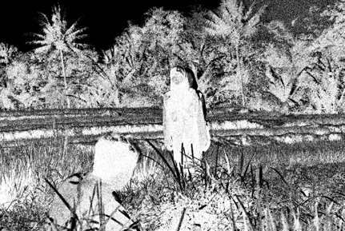 |  |  | MCU : saat andi beristirahat  CU to MS : saat melihat anak sekolah dan mereka saling sapa  MCU : setelah anak sekolah lewat |  | Backsound : Iwan Fals (Tugu Pancoran)  Naskah :  Anak sekolah ; mari mas!  Andi ; hya!

CHECKLIST (PRODUCTION)
Talent | Wardrobe | Property | Equipment | Shootlist
ok | ok | ok | Ok | M2U04108 - M2U04112
BREAKDOWN DAN NASKAH
Iklan Layanan Masyarakat
Sekolahku
Scene 2/1
No | Time Shoot | Location Shoot | Talent | Wardrobe | Property | Equiipment Shoot | Duration Shoot
 | 20/03/2013  Pukul 15.00-15.20 | Desa Lopait  Jl.fatmawati Rt/Rw 11/01 | -Andi | -kaos  -celana kolor | -sabit | -Kamera Sony HD  -Lensa 50mm  -tripot  -kamera DSLR | 3 detik
 | STORYBOARD |  |  | VIDEO |  | AUDIO
 |  |  |  | MS : andi berjalan menuju pulang |  | Backsound : You're All That I need - White Lion
CHECKLIST (PRODUCTION)
Talent | Wardrobe | Property | Equipment | Shootlist
OK | OK | OK | Ok | M2U04113- M2U04116

BREAKDOWN DAN NASKAH
Iklan Layanan Masyarakat
Sekolahku
Scene 2/2
No | Time Shoot | Location Shoot | Talent | Wardrobe | Property | Equiipment Shoot | Duration Shoot
 | 20/03/2013  Pukul 15.20-15.40 | Desa Lopait  Jl.fatmawati Rt/Rw 11/01 | Andi  Zulfa  Sindi  Rahayu  Endang | -kaos  -celana  -selendang | -keranjang  -sabit | -Kamera Sony HD  -Lensa 50mm  -tripot  -kamera DSLR | 4 detik
 | STORYBOARD |  |  | VIDEO |  | AUDIO
 | 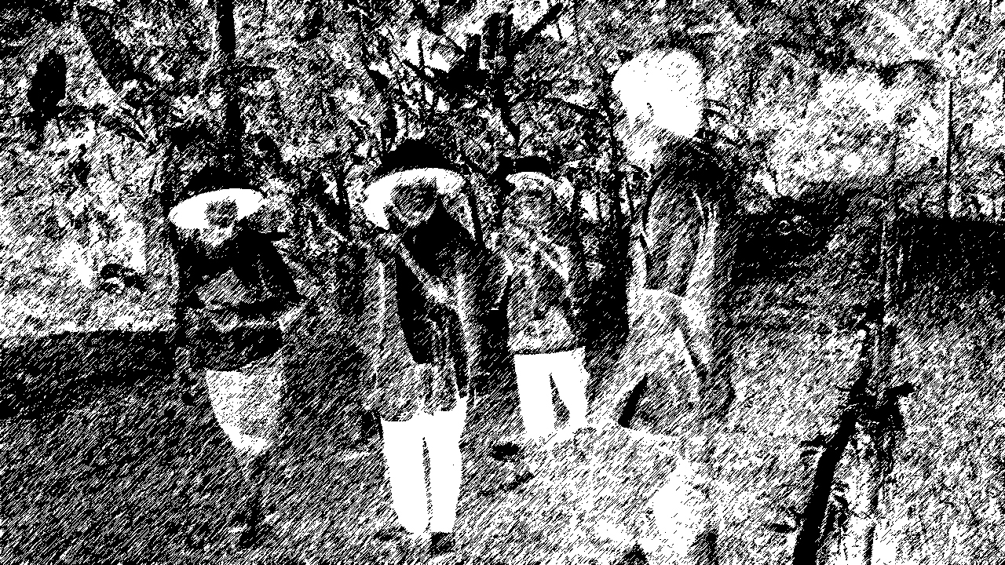. |  |  | CU to LS: andi melihat sekumpulan petani membawa peralatan pertanian |  | Backsound : You're All That I need - White Lion

CHECKLIST (PRODUCTION)
Talent | Wardrobe | Property | Equipment | Shootlist
OK | OK | OK | Ok | M2U04113- M2U04116

BREAKDOWN DAN NASKAH
Iklan Layanan Masyarakat
Sekolahku
Scene 2/3

No | Time Shoot | Location Shoot | Talent | Wardrobe | Property | Equiipment Shoot | Duration Shoot
 | 20/03/2013  Pukul 15.40-15.55 | Desa Lopait  Jl.fatmawati Rt/Rw 11/01 | Andi  Zulfa  Sindi  Rahayu  Endang | -kaos  -celana  -selendang | -keranjang  -sabit | -Kamera Sony HD  -Lensa 50mm  -tripot  -kamera DSLR | 5 detik
 | STORYBOARD |  |  | VIDEO |  | AUDIO
 |  |  |  | LS : Semakin sekelompok orang tersebut mendekat ke arah Andi,  CU ; Andi terkejut melihat orang membawa alat tulis  ECU : bolpen dan buku |  | Baacksound : You're All That I need - White Lion
CHECKLIST (PRODUCTION)
Talent | Wardrobe | Property | Equipment | Shootlist
OK | OK | OK | Ok | M2U04113- M2U04116

BREAKDOWN DAN NASKAH
Iklan Layanan Masyarakat
Sekolahku
Scene 2/4
No | Time Shoot | Location Shoot | Talent | Wardrobe | Property | Equiipment Shoot | Duration Shoot
 | 20/03/2013  Pukul 15.55-16.05 | -Pinggir sawah  -Desa Lopait  Jl.fatmawati Rt/Rw 11/01 | Andi  Zulfa  Sindi  Rahayu  Endang | -kaos  -celana  -selendang | -keranjang  -sabit | -Kamera Sony HD  -Lensa 50mm  -tripot  -kamera DSLR | 5 detik
 | STORYBOARD |  |  | VIDEO |  | AUDIO
 |  |  |  | MCU ; saat percakapan terjadi antara mereka  LS ; andi berjalan bersama mereka |  | Backsound :  You're All That I need - White Lion  Naskah :  Andi ; mau kemana buk?  Ibu ; udah,gak usah banyak Tanya! Ayo ikut ajak!

CHECKLIST (PRODUCTION)
Talent | Wardrobe | Property | Equipment | Shootlist
OK | OK | OK | Ok | M2U04113- M2U04116
BREAKDOWN DAN NASKAH
Iklan Layanan Masyarakat
SEKOLAHKU
Scene 3/1
No | Time Shoot | Location Shoot | Talent | Wardrobe | Property | Equipment Shoot | Duration Shoot
1. | 20/03/2013  Pukul 16.05-16.20 | Gedung Sekolah terbuka | Andi  Zulfa  Sindi  Rahayu  Endang | Pakaian (Baju Petani, celana Pendek), make up (bawa sendiri) | Cangkul, sabit, keranjang, selendang, buku, boelpoint | -Kamera Sony HD  -Lensa 50mm  -tripot  -kamera DSLR  -Lighting | 4 detik
 | STORYBOARD |  |  | VIDEO |  | AUDIO
 |  |  |  | MS to Pan left/right: Gedung Sekolah terbuka tampak dari luar menghadap perkampungan |  | Backsound :  You're All That I need - White Lion

CHECKLIST (PRODUCTION)
Talent | Wardrobe | Property | Equipment | Shootlist
OK | OK | OK | OK | M2U04176
BREAKDOWN DAN NASKAH
Iklan Layanan Masyarakat
SEKOLAHKU
Scene 3/2
No | Time Shoot | Location Shoot | Talent | Wardrobe | Property | Equipment Shoot | Duration Shoot
1. | 20/03/2013  Pukul 16.20-16.30 | Kelas sekolah terbuka | Andi  Rahayu  Endang  Sindi  Astri  Tia  Zulfa | Pakaian (Baju Petani, celana pendek, baju biasa), make up (bawa sediri) | Papan tulis, Meja, Kursi, Sapu, tempat sampah, Jam dinding, lemari. | -Kamera Sony HD  -Lensa 50mm  -tripot  -kamera DSLR  -Lighting | 4 detik
 | STORYBOARD |  |  | VIDEO |  | AUDIO
 |  |  |  | MS to CU : ruang kelas tampak dari pintu menghadap meja kursi dan papan tulis  CU : Meja, Kursi, papan tulis |  | Backsound : Iwan Fals (Tugu Pancoran)

CHECKLIST (PRODUCTION)
Talent | Wardrobe | Property | Equipment | Shootlist
OK | OK | OK | OK | M2U04178
BREAKDOWN DAN NASKAH
Iklan Layanan Masyarakat
SEKOLAHKU
Scene 3/3
No | Time Shoot | Location Shoot | Talent | Wardrobe | Property | Equipment Shoot | Duration Shoot
 | 20/03/2013  Pukul 16.30-16.40 | Kelas sekolah terbuka | Astri  Tia | Pakaian (Baju biasa)  make up (bawa sendiri) | Meja, kursi, papan tulis, buku, dan alat tulis, | -Kamera Sony HD  -Lensa 50mm  -tripot  -kamera DSLR  -Lighting | 3 detik
 | STORYBOARD |  |  | VIDEO |  | AUDIO
 |  |  |  | Pan right : tampak beberapa siswa duduk tenang didalam kelas  CU : siswa, buku dan alat tulis |  | Backsound : Iwan Fals (Tugu Pancoran)

CHECKLIST (PRODUCTION)
Talent | Wardrobe | Property | Equipment | Shootlist
OK | OK | OK | OK | M2U04180

BREAKDOWN DAN NASKAH
Iklan Layanan Masyarakat
Sekolahku
Scene 4/1
No | Time Shoot | Location Shoot | Talent | Wardrobe | Property | Equiipment Shoot | Duration Shoot
 | 20/03/2013  Pukul 16.40-16.50 | Kelas sekolah terbuka , Desa Lopait  Jl.fatmawati Rt/Rw 11/01 | Andi  Rahayu  Endang  Sindi  Astri  Tia  Zulfa | Pakaian (Baju biasa)  make up (bawa sendiri) | Meja, kursi, papan tulis, buku, dan alat tulis, | -Kamera Sony HD  -Lensa 50mm  -tripot  -kamera DSLR  -Lighting | 4 detik
 | STORYBOARD |  |  | VIDEO |  | AUDIO
 |  |  |  | MS : saat mereka masuk kelas |  | Backsound : Iwan Fals (Tugu pancoran)

CHECKLIST (PRODUCTION)
Talent | Wardrobe | Property | Equipment | Shootlist
 |  |  | Ok | M2U04182
BREAKDOWN DAN NASKAH
Iklan Layanan Masyarakat
Sekolahku
Scene 4/2
No | Time Shoot | Location Shoot | Talent | Wardrobe | Property | Equiipment Shoot | Duration Shoot
 | 20/03/2013  Pukul 16.50-17.05 | Kelas sekolah terbuka , Desa Lopait  Jl.fatmawati Rt/Rw 11/01 | Andi,Rahayu  Endang,Sindi  Astri,Tia  Zulfa,Indah | Pakaian rapi  Make Up (bawa sendiri) | Meja, kursi, papan tulis, buku, dan alat tulis, | -Kamera Sony HD  -Lensa 50mm  -tripot  -kamera DSLR  -Lighting | 4 detik
 | STORYBOARD |  |  | VIDEO |  | AUDIO
 |  |  |  | LS : Seseorang masuk ruang kelas  ECU : Saat map diletakkan di atas meja |  | Backsound : kitaro  Naskah :  Guru : Selamat sore teman-teman.  Siswa : Sore…  Guru : Saya akan memberikan materi pelajaran matematika
CHECKLIST (PRODUCTION)
Talent | Wardrobe | Property | Equipment | Shootlist
OK | OK | OK | Ok | M2U04189

BREAKDOWN DAN NASKAH
Iklan Layanan Masyarakat
Sekolahku
Scene 4/3
No | Time Shoot | Location Shoot | Talent | Wardrobe | Property | Equiipment Shoot | Duration Shoot
 | 20/03/2013  Pukul 17.05-17.15 | Kelas sekolah terbuka , Desa Lopait  Jl.fatmawati Rt/Rw 11/01 | Andi,Rahayu  Endang,Sindi  Astri,Tia  Zulfa,Indah | Pakaian rapi  Make Up (bawa sendiri) | Meja, kursi, papan tulis, buku, dan alat tulis, | -Kamera Sony HD  -Lensa 50mm  -tripot  -kamera DSLR  -Lighting | 6 detik
 | STORYBOARD |  |  | VIDEO |  | AUDIO
 |  |  |  | CU : Andi dan buku bertuliskan sekolah terbuka |  | Backsound :  Kitaro

CHECKLIST (PRODUCTION)
Talent | Wardrobe | Property | Equipment | Shootlist
OK | OK | OK | Ok | M2U04192
BREAKDOWN DAN NASKAH
Iklan Layanan Masyarakat
Sekolahku
Scene 5/1
No | Time Shoot | Location Shoot | Talent | Wardrobe | Property | Equiipment Shoot | Duration Shoot
 | 20/03/2013  Pukul 17.15-17.30 | Kelas sekolah terbuka , Desa Lopait  Jl.fatmawati Rt/Rw 11/01 | Andi,Rahayu  Endang,Sindi  Astri,Tia  Zulfa,Indah | Pakaian rapi  Make Up (bawa sendiri) | Meja, kursi, papan tulis, buku, dan alat tulis, | -Kamera Sony HD  -Lensa 50mm  -tripot  -kamera DSLR  -Lighting | 7 detik
 | STORYBOARD |  |  | VIDEO |  | AUDIO
 |  |  |  | CU to MS : Saat memperhatikan guru mengajar.  CU : Wajah andi tersenyum lebar dengan bangga |  | Backsound :KITARO
CHECKLIST (PRODUCTION)
Talent | Wardrobe | Property | Equipment | Shootlist
OK | OK | OK | Ok | M2U04193

BREAKDOWN DAN NASKAH
Iklan Layanan Masyarakat
Sekolahku
Scene 5/2
No | Time Shoot | Location Shoot | Talent | Wardrobe | Property | Equiipment Shoot | Duration Shoot
 | 20/03/2013  Pukul 17.30-17.45 | Kelas sekolah terbuka , Desa Lopait  Jl.fatmawati Rt/Rw 11/01 | Andi,Rahayu  Endang,Sindi  Astri,Tia  Zulfa,Indah | Pakaian rapi  Make Up (bawa sendiri) | Meja, kursi, papan tulis, buku, dan alat tulis, | -Kamera Sony HD  -Lensa 50mm  -tripot  -kamera DSLR  -Lighting | 10 detik
 | STORYBOARD |  |  | VIDEO |  | AUDIO
 |  |  |  | LS : Andi terburu-buru ingin berpamitan  MS : mencium tangan gurunya. |  | Backsound :  BONDAN (Kita selamanya)

CHECKLIST (PRODUCTION)
Talent | Wardrobe | Property | Equipment | Shootlist
OK | OK | OK | Ok | M2U04196
BREAKDOWN DAN NASKAH
Iklan Layanan Masyarakat
Sekolahku
Scene 5/3
No | Time Shoot | Location Shoot | Talent | Wardrobe | Property | Equiipment Shoot | Duration Shoot
 | 20/03/2013  Pukul 17.45-18.00 | Kelas sekolah terbuka , Desa Lopait  Jl.fatmawati Rt/Rw 11/01 | Andi,Rahayu  Endang,Sindi  Astri,Tia  Zulfa,Indah | Pakaian rapi  Make Up (bawa sendiri) | Meja, kursi, papan tulis, buku, dan alat tulis, | -Kamera Sony HD  -Lensa 50mm  -tripot  -kamera DSLR  -Lighting | 5 detik
 | STORYBOARD |  |  | VIDEO |  | AUDIO
 |  |  |  | LS : saat andi berlari lalu melompat dan berteriak |  | Backsound : BONDAN (Kita Selamanya)
CHECKLIST (PRODUCTION)
Talent | Wardrobe | Property | Equipment | Shootlist
OK | OK | OK | Ok | M2U04196

